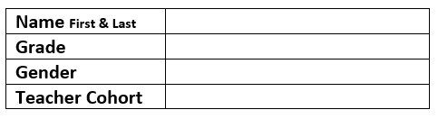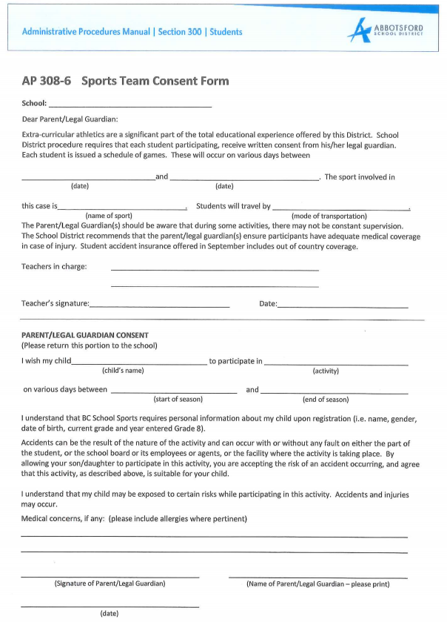

**I also understand COVID-19 protocols will be implemented and followed by my son or daughter and there are associated risks.**

Abbotsford Traditional Middle School

January 29, 2021

November 16, 2020

Basketball Skills Development

November 5, 2020

Lucas Abbott

Tanner Wellington

be responsible for their own transportation.

Basketball Skills Development

January 29, 2021

November 16, 2020